**Instructions**: Given the problems below, identify the **input, process** and the expected **output.**

**PROBLEM 0:**

Create a calculator which allow addition of two numbers.

Input : value1, value2

Process : calculate sum = value1 + value2

Output : sum

**PROBLEM 1**

Amelia wants to buy a can of Coke from a vending machine. The drink cost RM2.20. The vending machine only takes coins as payment. Amelia has 3 x 50cents coins and 4 x 20cents coins.

**PROBLEM 2**

Find the perimeter and area of a rectangle. The perimeter and area of the rectangle are given by the following formulas:

**Perimeter = 2 * (length + width)**

**Area = length * width**

**PROBLEM 3**

Customer is eligible for free delivery coupon for first food order from UberPanda app. To apply the coupon, customer need to type ‘THANKYOU’ on the promo column before checkout.

**PROBLEM 4**

A muslimah hair salon is celebrating their 10th year anniversary. The owner decided to offer 15% discount for each hair styling services as listed below. For membership promo, customers will get additional 10% discount. Below are price for the promotional services:

* **Style A - Scalp treatment : RM60**
* **Style B - Rebonding : RM100**
* **Style C - Manicure & Pedicure : RM50**

**PROBLEM 5**

Given the following formula is to calculate the volume of a sphere.

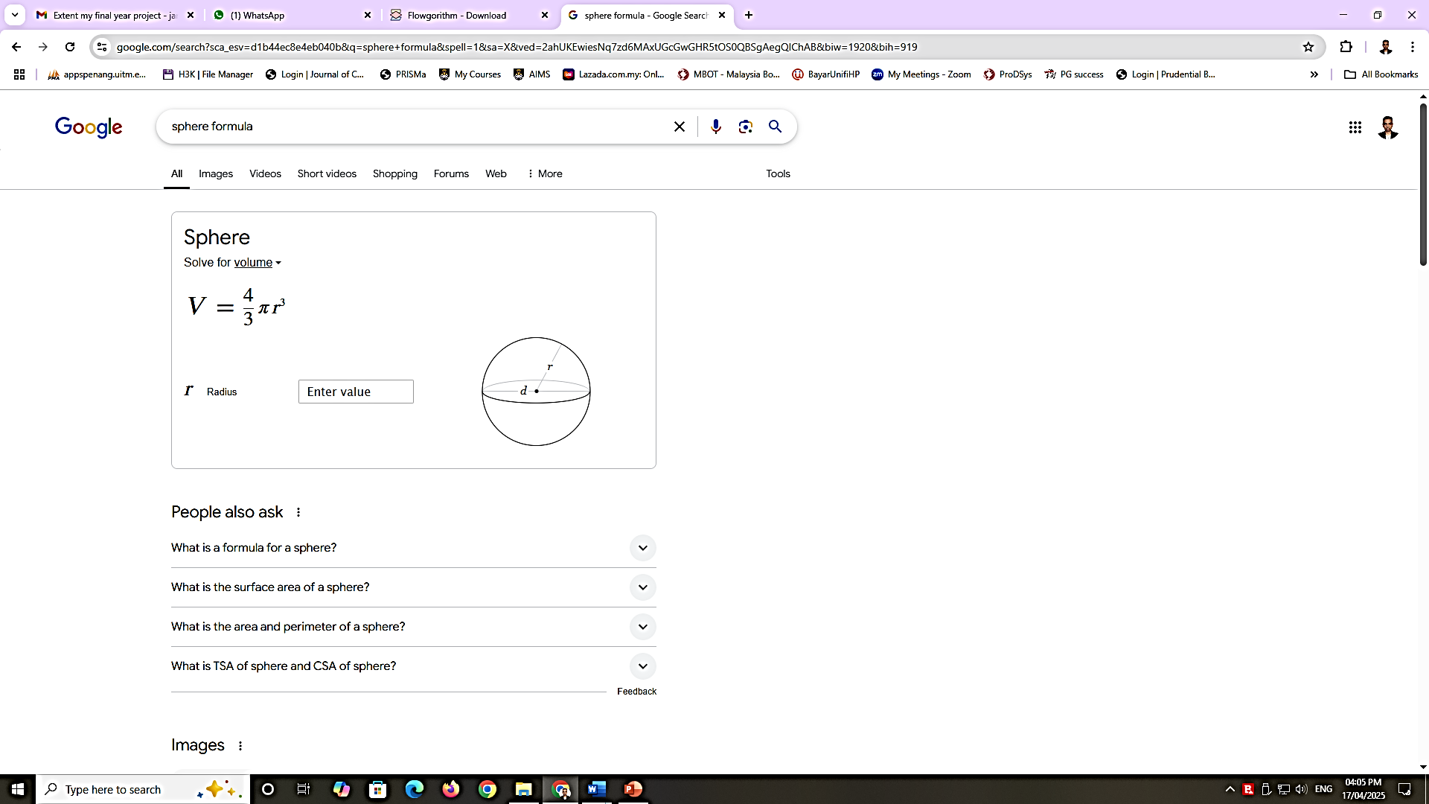

**PROBLEM 6**

The passenger wants to purchase the bus ticket. The passenger needs to choose the destination code as shown below.

|  |  |
| --- | --- |
| *Destination Code* | *Ticket Price* |
| KL | RM 56.00 |
| KB | RM 64.35 |

The passenger needs to enter the total ticket.

Display the total price.

**PROBLEM 7**

Write an IPO to help the programmer to understand the process of total charge calculation. The customer will enter quantity of the item that will be purchased. Given the price of the item is RM 25.00. Display the total charge of the item that need to be paid.

**PROBLEM 8**

The computer club will be organizing Sudoku game competition at UiTM Perlis branch. Given the charge per team is RM 50. If the campus able to send more than 5 teams, the charge per team will be RM 45. Calculate and display the total charge.

**PROBLEM 9**

As an analyst programmer you have been asked to prepare an IPO to help the engineering students to calculate the area and circumference of a circle. You have to identify what is the appropriate input, process and determine the output.

**PROBLEM 10**

As an industrial training student which attached at IT Department of Dell company located at Penang, you have been instructed to develop an IPO to determine the highest number of three numbers. This documentation will be used for engineer to create a special device for this new application.